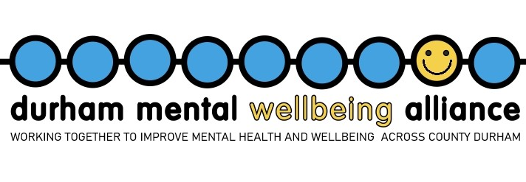

Durham Mental Wellbeing Alliance

Independent Chair role
About the Alliance
The Durham Mental Wellbeing Alliance (DMWA) was established in April 2022 following Durham County Council’s re-tendering of 21 mental health and wellbeing services. The Alliance brings together seven providers and a commissioning team to deliver a collaborative, whole-system approach to prevention, early intervention, and recovery support across County Durham. This innovative model, the first of its kind in the North East, is governed by shared decision-making and a commitment to positive outcomes for service users.
Alliance Values and Principles
- Aim: Build resilience and support people to thrive
- Vision: Connect communities, drive innovation, and empower individuals
- Mission: Collaborate to improve mental health and wellbeing across County Durham
- Values:
  - Empowerment: Fostering confidence and resilience
  - Accountability: Shared responsibility for service excellence
  - Connection: Strong links with colleagues, service users, and communities
  - Innovation: Transforming services through new approaches
Alliance Members
- Providers:
- Mental Health Matters
- Home Group
- Creative Support
- St Margaret’s Centre
- Waythrough
- If U Care Share
- Waddington Street Centre
- Commissioner Lead: Durham County Council
These organisations are representative bodies with their own structures and governance responsibilities. They come together within County Durham under an Alliance Agreement with Durham County Council and the providers have a non-legally-binding Provider Collaboration Agreement (PCA), which defines the shared commitment to optimise the way they work together to achieve the best outcomes for all the people of County Durham.

- The alliance is also supported five subcontractors:
- Aspire
- Welfare Rights
- Cruse
- Think Positive
- Relate
Chair of DMWA – Role Overview
We are seeking a new Independent Chair to lead our Alliance as we enter the next phase of development. The Chair will provide strategic leadership, ensure effective governance, and act as an ambassador for the Alliance.
The role includes overseeing the partnership working between the constituent organisations, engaging with Board colleagues and other stakeholders to maximise the benefits of collaborative working, shared decision making and effective governance. In addition, the Chair will participate in and help to shape County Durham’s approach to partnership development, ensuring that liaison with other key County Durham partnership organisations is optimised and contributes strongly to improved health and wellbeing for all our residents.

Key Responsibilities
- Lead the alliance leadership team in setting strategic direction and maintaining effective governance
- Foster a positive, inclusive culture and hold staff accountable
- Ensure timely implementation of ALT decisions
- Build strong relationships with staff, volunteers, beneficiaries, and stakeholders
- Represent the Alliance’s interests and values externally
- Chair the alliance leadership team meetings working with the alliance manager to create the agenda
- Setting a cohesive tone for the ALT encouraging the behaviours that support open and constructive challenge, debate and effective decision making

Candidate Profile
We are looking for a Chair who demonstrates:
- Experience in charity governance and Board leadership
- Strategic thinking and collaborative leadership
- Knowledge of health, wellbeing, or related sectors
- Commitment to inclusion, independence, and impact
- Experience in partnership working with the public sector, VCSE, or academia (desirable)
We Offer
- The opportunity to lead a successful, innovative alliance
- A rewarding, voluntary role with a dedicated team
- Opportunities to expand your professional network across public, charity, and health sectors
- Expenses required to complete your role
Commitment Required
- Attend 12 monthly meetings
- Provide additional support as needed
- Stay informed on relevant issues and maintain confidentiality
We particularly welcome applicants with expertise in:
- Public policy
- Corporate governance
- Voluntary and community sector
- Local government and statutory bodies
- Mental health and wellbeing
- Human resources
- Volunteering
- Housing
- Advocacy
- Fundraising and income development
- Social impact and outcomes
*We would welcome applications from those with lived experience
Application Process
To learn more or arrange an informal conversation, please contact:
Julie.cane@durhammentalwellbeingallaince.com or call 07725958329. A meeting can also be arranged with our previous chair Richard Lilly
To apply, please submit:
- Your CV to the alliance manager Julie.cane@durhammentalwellbeingalliance.com
- A supporting statement outlining your interest and suitability
Key Dates
- Application deadline: 31.01.26
- Informal meetings: w/c 09.02.26

